WEEK 4
Task 1:
To Split Input into Tokens, Identify Delimiters, Handle Whitespace, Create Token Structures, Validate Token Streams, Debug Parsing Output and Design Parser Logic, Generate Parse Trees, Validate Syntax, Detect Errors, Handle Empty Commands, Produce Execution Structures

Flow Chart:
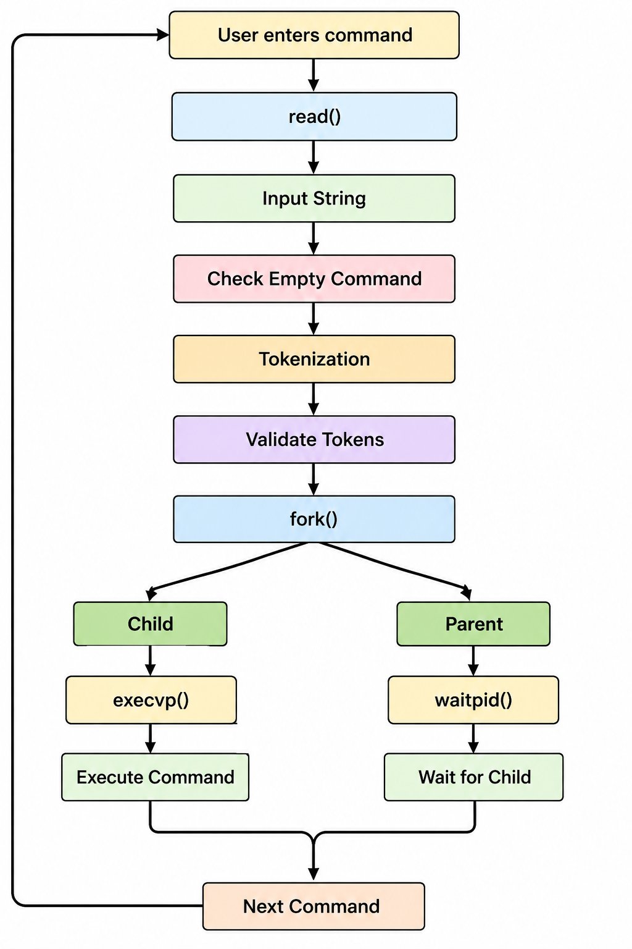

Task 2:
To Apply Single Quotes, Preserve Literal Content, Ignore Variable Expansion, Store Quoted Strings, Validate Parsing Results, Test Edge Cases.

Flow Chart:
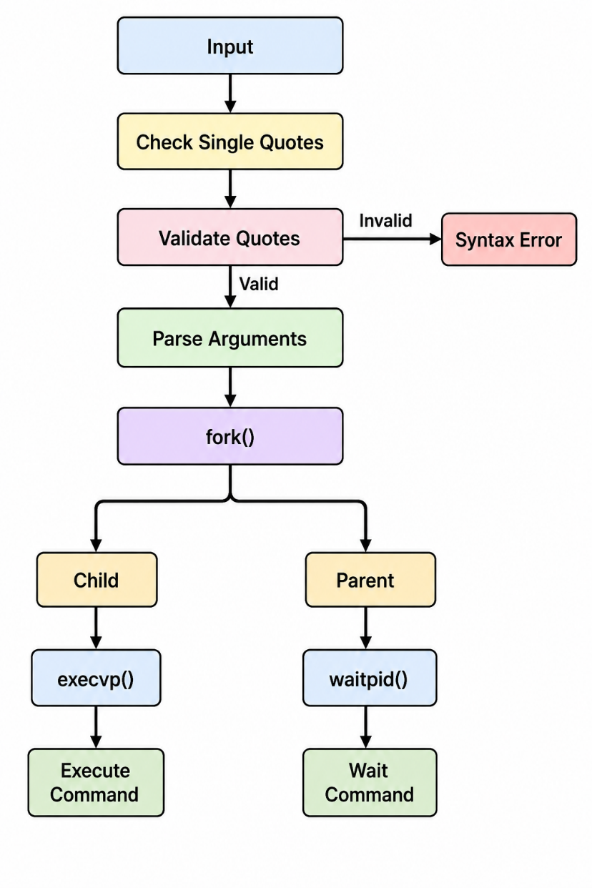

CREATE FILE

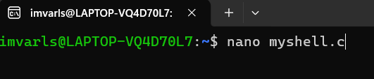

CODE

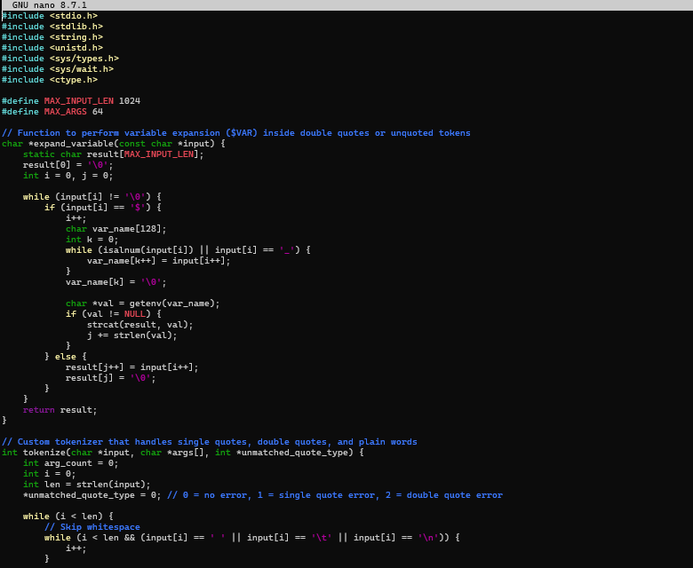

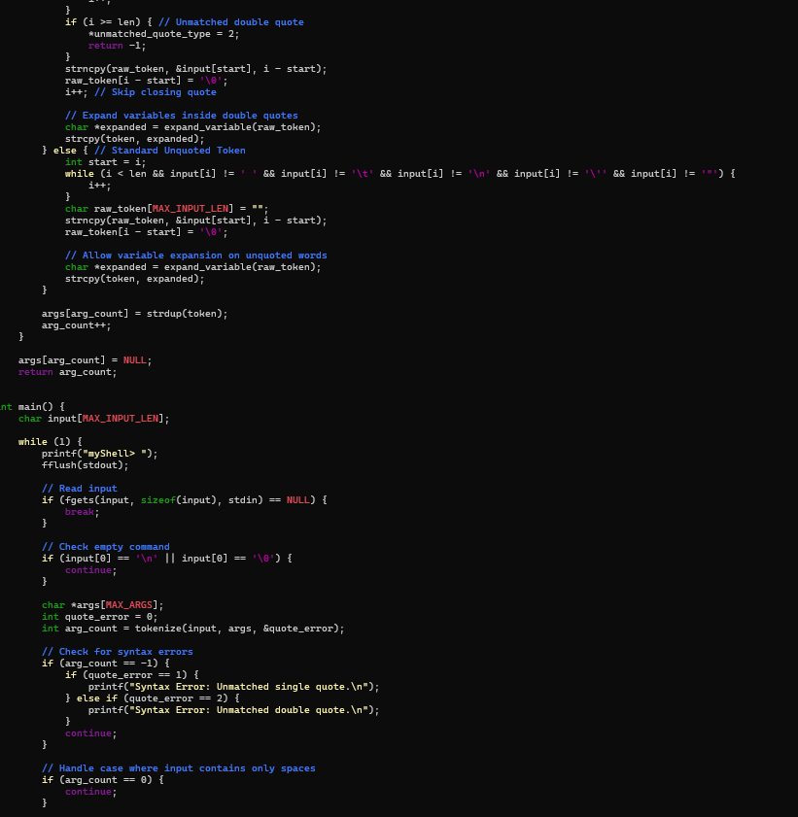

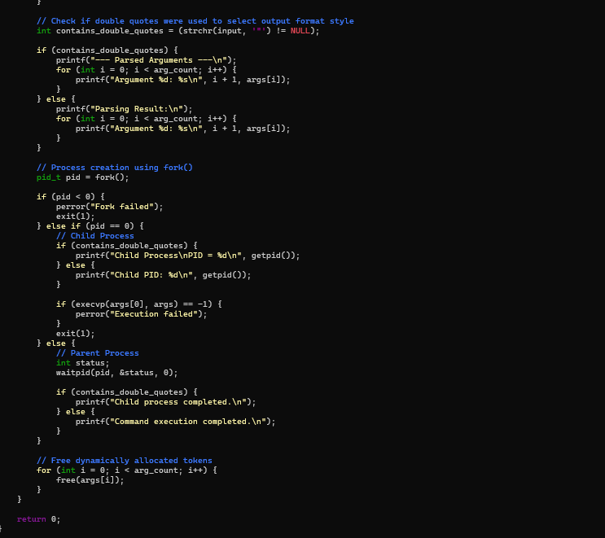

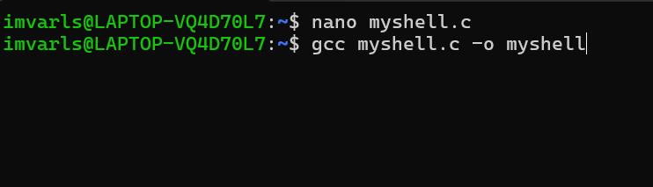
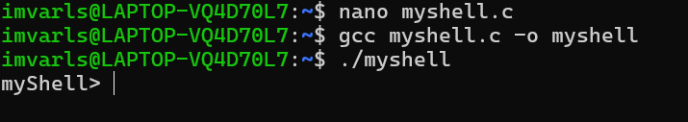

OUTPUT

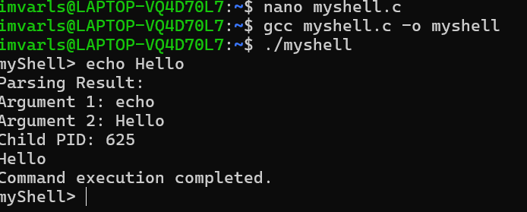

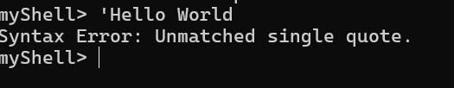

Task 3:
To Apply Double Quotes, Preserve Spaces, Allow Variable Expansion, Parse Nested Tokens, Validate Outputs, Test Quoted Commands.



SAME CODE AS PREVIOUS ONE





OUTPUT

